

**FPT ACADEMY INTERNATIONAL**

**FPT – APTECH COMPUTER EDUCATION**

**Centre Name: FPT APTECH HCMC**

**Address: 590 Cach Mang Thang 8, District 3, Ho Chi Minh City, Viet Nam.**

FOOD STORE

Project Report Semester 2

|  |  |  |
| --- | --- | --- |
| **Supervisor** | Ngo Phuoc Nguyen | |
| **Batch** | T1.2201.E0 | |
| **Group** | 1 | |
| **Serial No.** | **Student Name** | **Enrollment Number** |
| 1. | Tran Pham Duy Thanh | Student1359464 |
| 2. | Nguyen Tan Hung | Student1359462 |
| 3. | Nguyen Quang Truong | Student1362610 |

**NOVEMBER-2022**

CONTENTS

REVIEW 1 0

INTRODUCTION 1

For Food Store’s users: 1

PROBLEM DEFINITION 3

From the view point of Users: 3

From the view point of Administrators: 3

CUSTOMER REQUIREMENT SPECIFICATION 4

Food Store’s administrator will be able to: 4

Food Store’s visitor will be able to: 5

Scope of work 6

SYSTEM REQUIREMENT SPECIFICATION 7

REVIEW 2 7

ENTITIES AND ENTITY RELATIONSHIP DIAGRAM 8

I. Use case and sequence diagram 8

1.Guest 8

Member 20

Admin 27

Flowchart 50

Login function(user) 50

Singup function (user) 51

Search function 52

View data function 53

Insert data function 54

Login function(admin) 55

Sitemap 56

TABLE DESIGN 57

1.Table categories 57

2.Table menus 57

3.Table orders 57

4.Table order_details 58

5.Table posts 58

6.Table products 59

7.Table product_images 59

8.Table product_tags 59

9.Table settings 60

10.Table shoppingcart 60

11.Table sliders 60

12.Table tags 61

13.Table users 61

14.Wishlists 61

15. Ratings 62

16.Comments 62

RELATIONSHIP DIAGRAM 63

REVIEW 3 61

Customer 62

1.Home page 62

2.Product page 65

3.Product detail page 66

4.Post Page 67

5.Post detail page 68

6.About us page 69

7.Contact page 71

8.Log in page 72

9.Register page 73

10.Wishlist page 74

11.Shopping cart page 75

12.Checkout page 76

13.Checkout page with QR 77

Admin 78

1.Log in page 78

2.Dashboard page 79

4.Category edit page 80

5.Category create page 81

6.Menu index page 81

7.Menu edit page 82

8.Menu create page 82

9.Product index page 83

11.Product create page 84

12.Slider index page 85

14.Slider create page 86

15.Post index page 87

16.Post edit page 87

17.Post create page 88

18.Comment index page 89

19.Order page 89

20.Setting index page 90

21.Setting edit page 90

22.Setting create page 91

23.User index page 92

25.User create page 93

26.My QR 93

28.Error page(amin, guest) 94

Task Sheet 95

# 

# REVIEW 1

# INTRODUCTION

In recent years, the growing society leads to people becoming busier. Therefore, everyone wants to own utility services from moving, playing, living to shopping. In the urban areas and the big cities, people are so busy in their business life that they don’t get enough time to have their meals properly. These days women are no less than men, in any field. A wife in many families work as a man, this leads to a lack of time to prepare a nutritious and reasonable meal. And fast food is not a wise choice for them, especially for their children.

So, the meals ordering device in recent times has one of the fastest-developing markets, even though being a new idea. In this project, we've advanced something just like the equal to examine from and serve the kingdom in a far higher manner possible. Nowadays, humans are greater normal to dine-in on the eating place for his or her meals.

The online food ordering system provides convenience for the customers that are nothing special but the general busy people of the society. It overcomes the demerits of the manual hotel or mess system and the old-fashioned queuing system. This system enhances the ready-made foods that people.

Also, with the food ordering system online, people can easily track their orders, and the admin can maintain the customer’s database and advance the food delivery system. This food ordering system allows the user to select the desired food items from a list of available menu items provided by the local hotel or restaurant.

The user can place orders for the food items of their like from the list. The payment can be made online or pay-on-delivery system. The user’s details are maintained confidentially because it maintains a separate account for each user. An id and password are provided for each user.

## For Food Store’s users:

* Website is simple, friendly interface and help users easily access it.
* Stimulate the customer’s state.
* Foods were sorted by price, new, discount and clearly category.
* Users can search, review products through product detail page, rating of other users.
* Users can create accounts and login their new account.
* Users can view the dishes presented in an eye-catching way with calorie information according to the dish
* Users can add products to table compare to find the food’s differences.
* Users can add foods to wish-list.
* Users can rate the foods.
* Users can send email to admin to get the support if they need.

# PROBLEM DEFINITION

After selecting the topic for the group, we analyzed the structure and problems presented by the project. The issues that need to be resolved in the user interface and admin after being aggregated include:

## From the view point of Users:

* How users can find the sale off, new products?
* How users can review product’s information?
* How users can purchase products?
* How users can login page with their account?
* How users can order foods?
* How users can comment in post-detail?
* How users can compare many dishes?
* How users can add their favorite foods to the wish-list?

## From the view point of Administrators:

* How can admin create, delete, update, search, sort dishes?
* How can admin create, delete, update, sort, search view of users (example sliders, setting, menu, category)?
* How can admin see, accept, print report user’s order?
* How can admin see, update, delete, search, sort user’s detail?
* How can admin see, create, update, delete, search, sort posts?
* How can admin manage role of users?
* How to send confirmed mail when users finish their order?
* How can admin manage, search, sort and delete comment are not suitable?
* How can admin manage add, delete file and image of web?

# CUSTOMER REQUIREMENT SPECIFICATION

**Client:** Food Store

**Business/Project Objective:** The project is designed to help user can review and buy appetizers, main courses and desserts, etc.

**Input to the system:**

**Food Store’s administrator need to provide:**

* Information required in order to create account to access to the admin system.
* Information about products and post going to be shown in on users view.

**Food Store user need to provide:**

* Personal information to create account.

**Output to the system:**

## Food Store’s administrator will be able to:

* Login/logout to the admin system.
* Manage (view, create, update, delete, search, sort) foods.
* Manage (view, create, update, delete, search, sort) categories.
* Manage (view, create, update, delete, search, sort) menu.
* Manage (view, create, update, delete, search, sort) slider.
* Manage (view, create, update, delete, search, sort) post.
* Manage (view, create, update, delete, search, sort) setting.
* Manage (view, create, update, delete, search, sort) user.
* Manage (view, view detail, delete, search, sort, accept, print report) order.
* Manage (view, delete, search, sort) comment.
* See revenue and number of members registered.
* Manage (view, create, update, delete, search, sort) file manage.

## Food Store’s visitor will be able to:

If customers are guests:

* Searching and view food calories details.
* Searching foods by name, category, classify.
* Adding dishes to shopping cart.
* Comparing food’s information.
* Reading post.
* Registering to become members.
* Sending mail for assistance.

If customers resign as a member:

* All function of customers.
* Login and Logout.
* Paying foods in shopping cart.
* Rating in food details.
* Typing and sending comment in post details.
* Adding dishes to their wish list.

# Scope of work

The web should perform the following functions:

**Login**

There are two types of account in this web (user, admin). Administrators will login in “Admin Form” and Users will login in “User Form”.

Login account will switch back to different interfaces and perform different functions.

For “admin”: can view all users information, add, update, delete user.

For “user”: can register new account and login account.

**Buy dishes**

When users click on “Add to cart”, that food will add to shopping cart, users can open shopping card to check quantity of their product before they pay.

**Review dish**

When customers click on a dish, Web will switch to dish detail page, customers can view product detail, choose quantity, and rating. Besides, customers can refer to related dishes.

**Database**

The data of category, menu, order, order detail, post, product, product image, tag, product tag, user, comment, ratings, wish-list, shopping cart, settings, sliders will be stored in database and administrators can be view and manage easily.

**Security**

The user password will be encrypted and stored in database.

# SYSTEM REQUIREMENT SPECIFICATION

**Hardware**

Web server

|  |  |
| --- | --- |
| Processor | Intel Core i7 or higher. |
| Memory | 8 GB RAM or greater. |
| Modem/ADSL | Connecting to internet 24/7 |

Client

|  |  |
| --- | --- |
| Processor | Intel Core i3 or higher. |
| Memory | 2 GB RAM or greater. |
| Monitor | Super VGA (1024x768) or higher resolution |
| Modem/ADSL | Connecting to internet |

**Software**

Web server

|  |  |
| --- | --- |
| Operation System | Windows 7 or higher |
| Browser | Chrome version 35 or Microsoft Edge. |
| Database | MySQL |
| Software | Internet Information Service |
| Visual Studio Code |

Client

|  |  |
| --- | --- |
| Operation System | Windows 7 or higher |
| Browser | Chrome version 35 or Microsoft Edge. |

**Development software**

* Microsoft window 11,10
* Google Chrome
* Visual Studio Code
* Git, Github
* Xampp

**Technology**

* PHP
* Laravel 7
* Javascript
* Jquery
* Bootstrap
* Ajax

# REVIEW 2

# WEBSITE ARCHITECTURE DIAGRAM

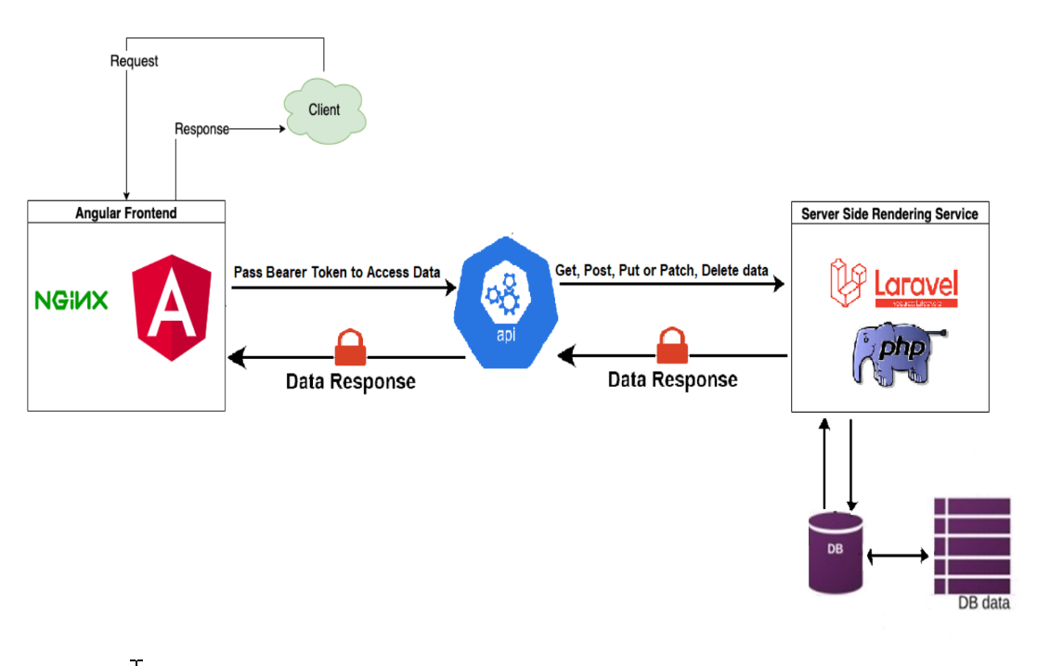

# ENTITIES AND ENTITY RELATIONSHIP DIAGRAM

## I. Use case and sequence diagram

### 1.Guest

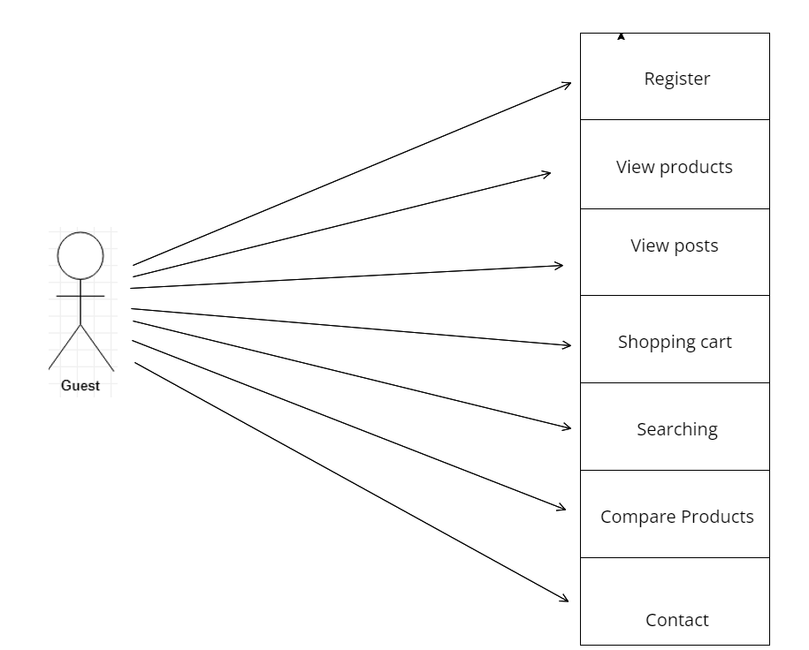

|  |  |  |
| --- | --- | --- |
| **Author** | Nguyễn Quang Trường | |
| **Use** **case** **name** | Enter keyword and Button search | |
| **Actors** | Guests and members | |
| **Description** | When search button is clicked and typed, web page will be switched to product page and display all product match with key word what user typed. | |
| **Requirement** |  | |
|  | **Actor** **action** | **System** **responses** |
| **Basic flow** | Actors input keyword and click on input search button. | Search string checking system.  Search - filter system - displays the same or similar information as the search results.  Clicking the search button will return a list of related products |
| **Exception** |  |  |

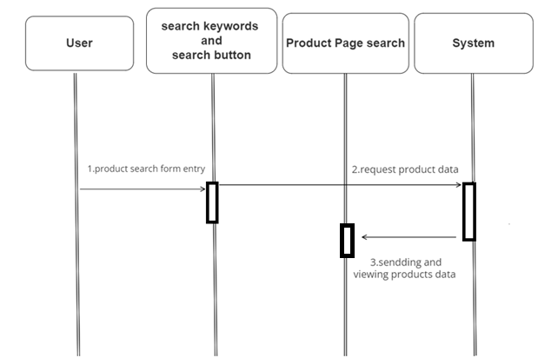

|  |  |  |
| --- | --- | --- |
| **Author** | Nguyễn Quang Trường | |
| **Use** **case** **name** | Product view | |
| **Actors** | Guests and members | |
| **Description** | When user click on product card, web page will switch to page product detail and show all information of product, include: name, content, price, and show related products. | |
| **Requirement** |  | |
|  | **Actor** **action** | **System** **responses** |
| **Basic flow** | Click on product links in name or image. | Receive slug in link and search in products table.  Display the details in the product detail page. |
| **Exception** |  |  |

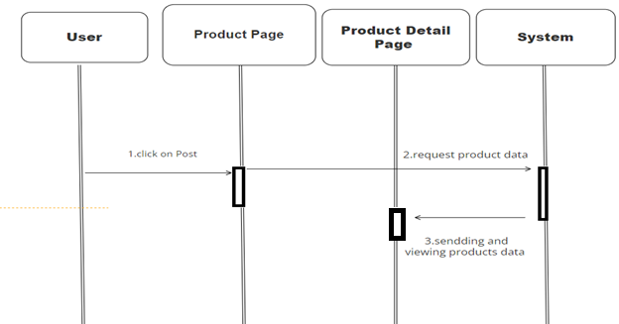

|  |  |  |
| --- | --- | --- |
| **Author** | Nguyễn Quang Trường | |
| **Use** **case** **name** | Shopping cart | |
| **Actors** | Guests and members | |
| **Description** | When users click on Add to card, number of shopping cart increase. Then click on shopping card, web page switch to cart detail. This page shows all products was chosen, quantity, total price and users can update quantity and delete from cart. | |
| **Requirement** |  | |
|  | **Actor** **action** | **System** **responses** |
| **Basic flow** | Click on Add to cart.  Update quantity in shopping cart.  Remove in shopping cart. | Add product detail to content row in shopping cart table and display to cart page include products, quantity, total price.  Update quantity and change content in shopping cart table and display to cart page include products, quantity, total price.  Remove and update content row in shopping cart table and display to cart page include products, quantity, total price. |
| **Exception** |  |  |

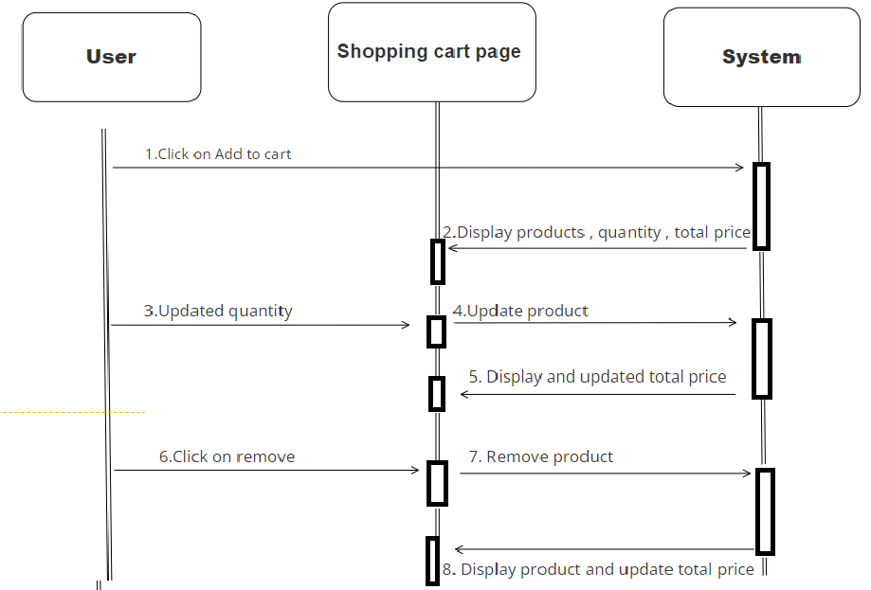

|  |  |  |
| --- | --- | --- |
| **Author** | Nguyễn Quang Trường | |
| **Use** **case** **name** | Register | |
| **Actors** | Guests and members | |
| **Description** | Guests want to register to become a member. | |
| **Requirement** |  | |
|  | **Actor** **action** | **System** **responses** |
| **Basic flow** | Input information and click on register. | Check validation.  Create account.  Display login page. |
| **Exception** | Field name blank.  Field email blank.  Field password blank.  Field phone blank.  Field address blank.  Email unique.  Email format. | Display error message:  “This value is required”  “This value is required”  “This value is required”  “This value is required”  “This value is required”  “Can not create an already existing email”  “This value should be a valid email” |

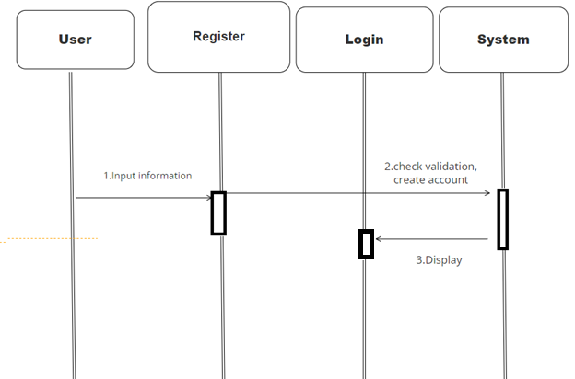

|  |  |  |
| --- | --- | --- |
| **Author** | Nguyễn Quang Trường | |
| **Use** **case** **name** | Compare Products | |
| **Actors** | Members and Guests | |
| **Description** | Members and Guests can compare price of products what they choice. | |
| **Requirement** |  | |
|  | **Actor** **action** | **System** **responses** |
| **Basic flow** | Click on compare button. | System creates array session and sort product by price. |
| **Exception** |  |  |

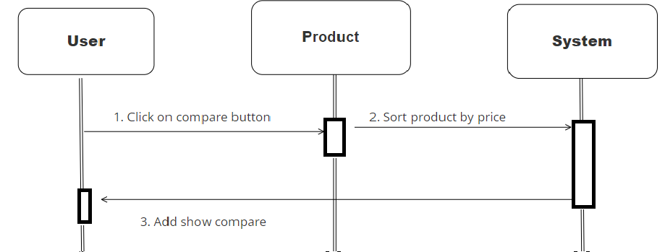

|  |  |  |
| --- | --- | --- |
| **Author** | Nguyễn Quang Trường | |
| **Use** **case** **name** | Contact Mail | |
| **Actors** | Members and Guests | |
| **Description** | Members and Guests can send email for assistance. | |
| **Requirement** |  | |
|  | **Actor** **action** | **System** **responses** |
| **Basic flow** | Enter the content in the form and click on submit button. | System check validation and send mail to user’s gmail. |
| **Exception** | Name field blank.  Email field blank.  Title field blank.  Content field blank.  Name field format.  Email field format. | Display error messages:  “This value is required”  “This value is required”  “This value is required”  “This value is required”  “This value is required”  “This value is required” |

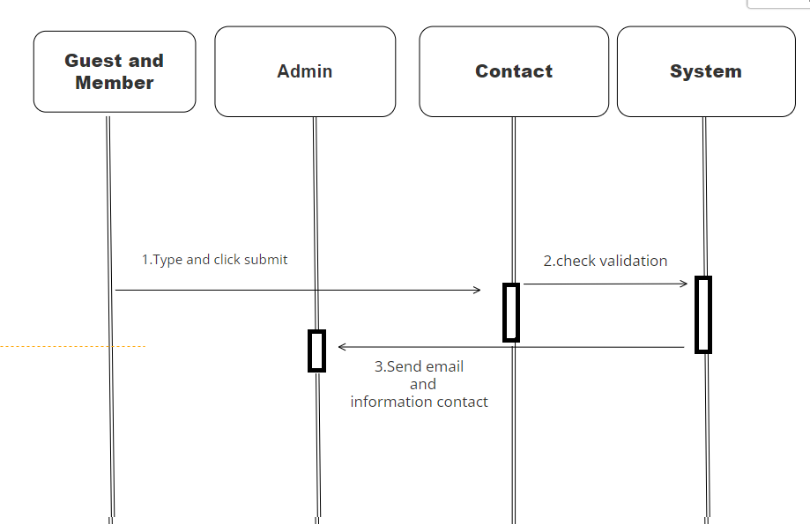

### Member

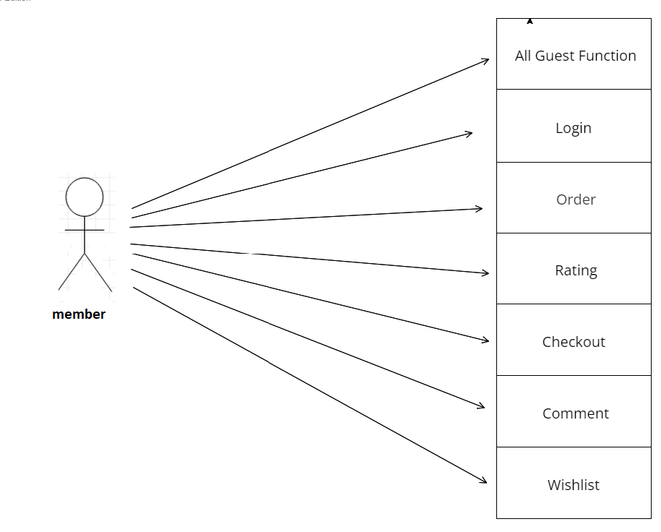

|  |  |  |
| --- | --- | --- |
| **Author** | Nguyễn Tấn Hùng | |
| **Use** **case** **name** | Login | |
| **Actors** | Members | |
| **Description** | User log in with their registered email and password. | |
| **Requirement** |  | |
|  | **Actor** **action** | **System** **responses** |
| **Basic flow** | Input email, password and click on Log in button. | System check validation and email password in data.  System shows member’s information and switch on Home page. |
| **Exception** | Field email not blank.  Field password not blank.  Email format. | Display error message:  “This value is required”  “This value is required”  “Should be a valid email” |

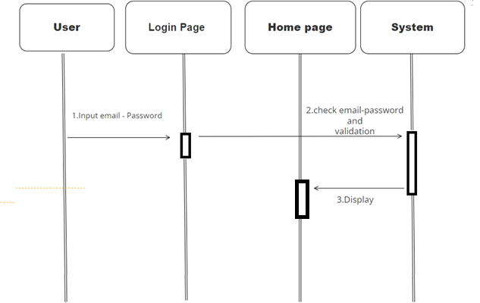

|  |  |  |
| --- | --- | --- |
| **Author** | Nguyễn Tấn Hùng | |
| **Use** **case** **name** | Order | |
| **Actors** | Members | |
| **Description** | Members order products in shopping cart | |
| **Requirement** | Log in | |
|  | **Actor** **action** | **System** **responses** |
| **Basic flow** | Click on pay button | System check user id, product id, quantity and create data in order and order id table. Then return shopping cart page before send confirm message |
| **Exception** | Field email not blank.  Email format.  Field password not blank | Display error message:  “This value is required”  “This value is required”  “This value is required” |

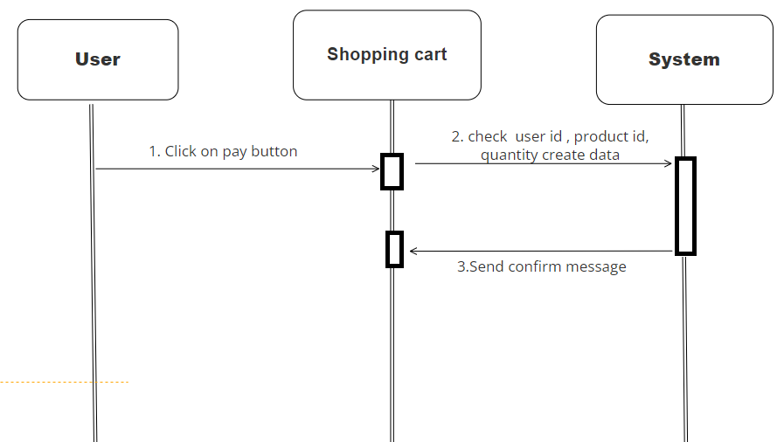

|  |  |  |
| --- | --- | --- |
| **Author** | Nguyễn Tấn Hùng | |
| **Use** **case** **name** | Comment | |
| **Actors** | Members | |
| **Description** | Members type and post their comment in post-details page. | |
| **Requirement** | Login | |
|  | **Actor** **action** | **System** **responses** |
| **Basic flow** | Type comment and click on submit. | System check validation, then create database and show this comment in this post. |
| **Exception** | Field comment not blank | Display error message  “This value is required” |

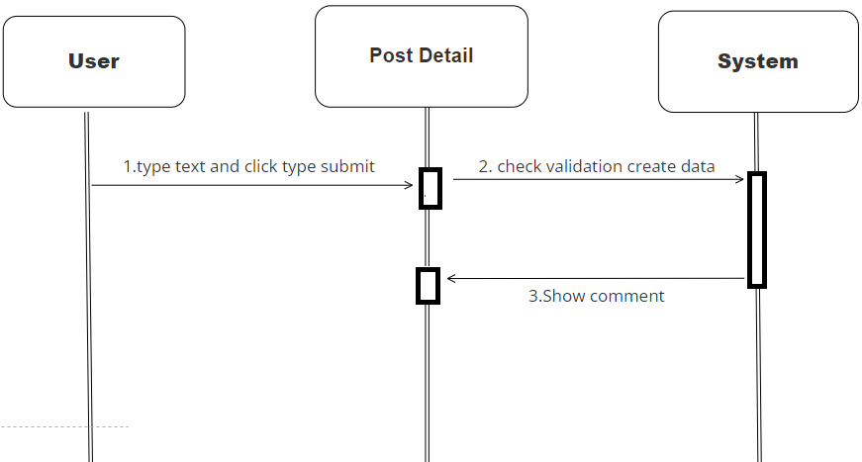

|  |  |  |
| --- | --- | --- |
| **Author** | Nguyễn Tấn Hùng | |
| **Use** **case** **name** | Wishlist | |
| **Actors** | Members | |
| **Description** | Members can add products to their wishlist to follow product. | |
| **Requirement** | Login | |
|  | **Actor** **action** | **System** **responses** |
| **Basic flow** | Click on wishlish button. | System adds product detail data to table wishlists. |
| **Exception** |  |  |

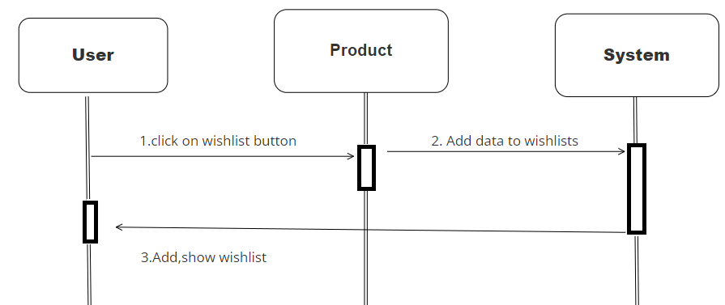

|  |  |  |
| --- | --- | --- |
| **Author** | Nguyễn Tấn Hùng | |
| **Use** **case** **name** | Rating | |
| **Actors** | Members | |
| **Description** | Member can rate product in product detail | |
| **Requirement** | Log in | |
|  | **Actor** **action** | **System** **responses** |
| **Basic flow** | Click on rating in product detail | Check user id, product id, and save rating in data |
| **Exception** |  |  |

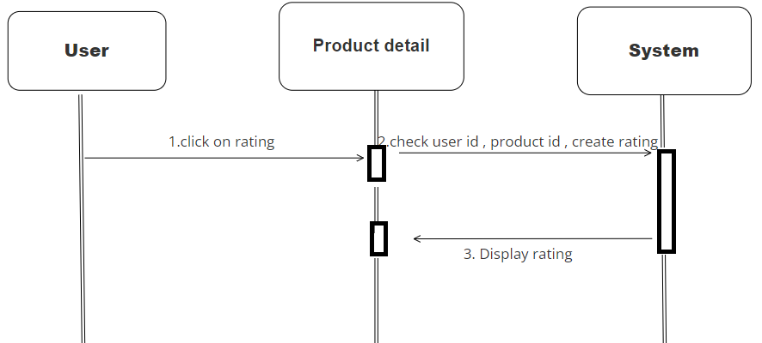

### Admin

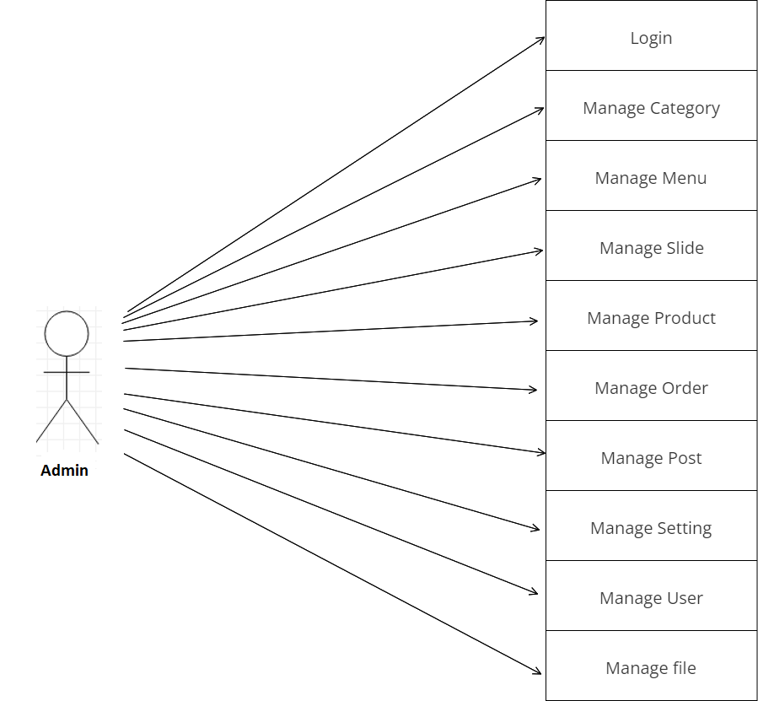

|  |  |  |
| --- | --- | --- |
| **Author** | Trần Phạm Duy Thanh | |
| **Use** **case** **name** | Login | |
| **Actors** | Admins | |
| **Description** | Admins go to admin page by login in admin form. | |
| **Requirement** |  | |
|  | **Actor** **action** | **System** **responses** |
| **Basic flow** | Entering name, password and clicking on submit button. | System checks user and password in database if it has database, system will forward to admin page. Contrary, returning login form and send the error message. |
| **Exception** | Field email not blank.  Field password not blank.  Email format. | Display error message:  “This value is required”  “This value is required”  “Should be a valid email” |

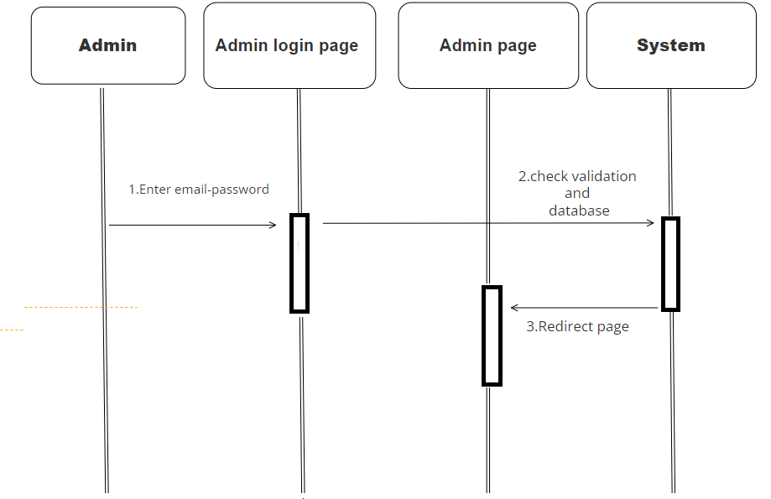

|  |  |  |
| --- | --- | --- |
| **Author** | Trần Phạm Duy Thanh | |
| **Use** **case** **name** | Manage Category | |
| **Actors** | Admins | |
| **Description** | Admin can see, search, sort, create, edit, delete category. | |
| **Requirement** | Login | |
|  | **Actor** **action** | **System** **responses** |
| **Basic flow** | Click on category index to see all category data.  Click on edit button enter content what you want to change and click on submit button.  Click on delete button to delete category.  Type and click on submit to create new category.  Enter keyword to search category.  Click on table header to sort data. | System takes all category data and show all.  System will redirect to edit page, check validation and update data after admins click on update button.  System deletes category was chosen in database.  System check validation and create data.  System check keyword and show matching entities.  System sort data by name, id, status… |
| **Exception** | Field name not blank.  Field password not blank. | Display error message:  “This value is required”  “This value is required” |

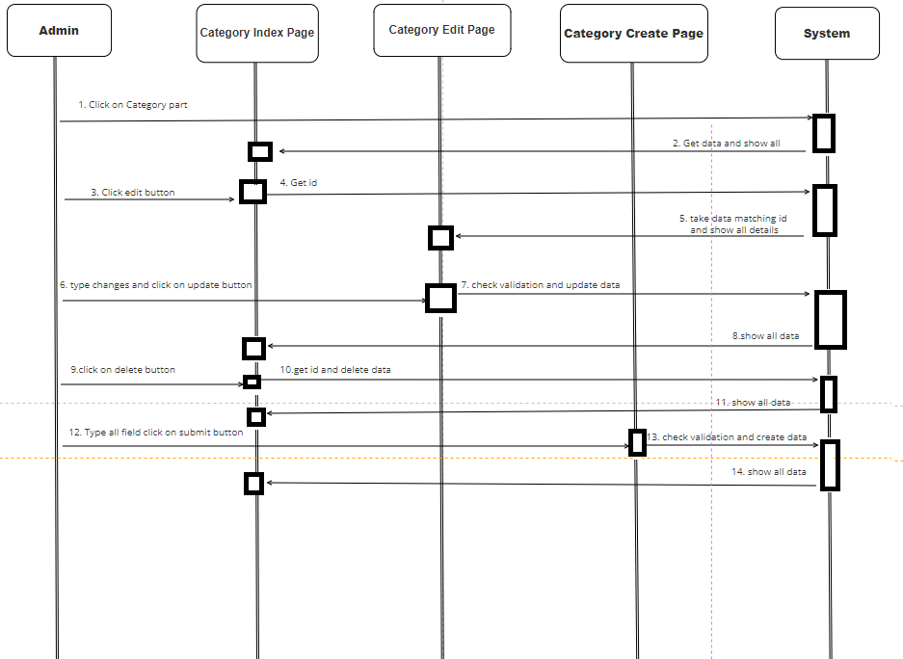

|  |  |  |
| --- | --- | --- |
| **Author** | Trần Phạm Duy Thanh | |
| **Use** **case** **name** | Manage Menu | |
| **Actors** | Admins | |
| **Description** | Admin can see, search, sort, create, edit, delete menu. | |
| **Requirement** | Login | |
|  | **Actor** **action** | **System** **responses** |
| **Basic flow** | Click on menu index to see all menu data.  Click on edit button enter content what you want to change and click on submit button.  Click on delete button to delete menu.  Type and click on submit to create new menu.  Enter keyword to search menu.  Click on table header to sort data. | System takes all menu data and show all.  System will redirect to edit page, check validation and update data after admins click on update button.  System deletes menu was chosen in database.  System check validation and create data.  System check keyword and show matching entities.  System sort data by name, id, status… |
| **Exception** | Field name not blank  Field password not blank | Display error message:  “This value is required”  “This value is required” |

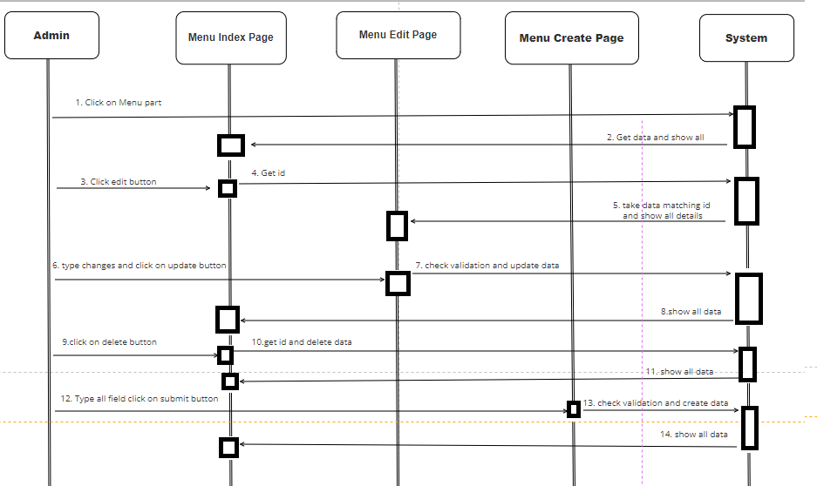

|  |  |  |
| --- | --- | --- |
| **Author** | Trần Phạm Duy Thanh | |
| **Use** **case** **name** | Manage Slider | |
| **Actors** | Admins | |
| **Description** | Admin can see, search, sort, create, edit, delete slider. | |
| **Requirement** | Login | |
|  | **Actor** **action** | **System** **responses** |
| **Basic flow** | Click on slider index to see all slider data.  Click on edit button enter content what you want to change and click on submit button.  Click on delete button to delete slider.  Type and click on submit to create new slider.  Enter keyword to search slider.  Click on table header to sort data. | System takes all slider data and show all.  System will redirect to edit page, check validation and update data after admins click on update button.  System deletes slider was chosen in database.  System check validation and create data.  System check keyword and show matching entities.  System sort data by name, id, status… |
| **Exception** | Field link not blank  Field content not blank  Image format | Display error message:  “This value is required”  “This value is required”  “Image must be jpg, png, jpeg” |

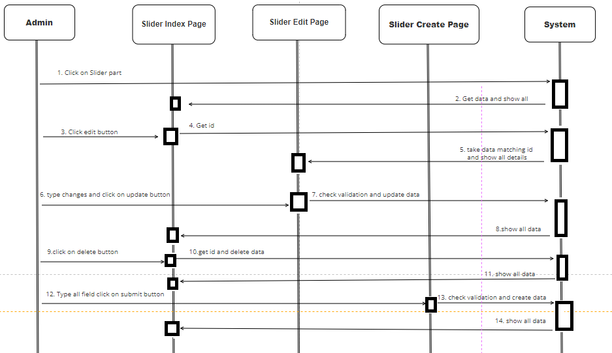

|  |  |  |
| --- | --- | --- |
| **Author** | Trần Phạm Duy Thanh | |
| **Use** **case** **name** | Manage Product | |
| **Actors** | Admins | |
| **Description** | Admin can see, search, sort, create, edit, delete product | |
| **Requirement** | Login | |
|  | **Actor** **action** | **System** **responses** |
| **Basic flow** | Click on product index to see all product data.  Click on edit button enter content what you want to change and click on submit button.  Click on delete button to delete product.  Type and click on submit to create new product.  Enter keyword to search product.  Click on table header to sort data. | System takes all product data and show all.  System will redirect to edit page, check validation and update data after admins click on update button.  System deletes product was chosen in database.  System check validation and create data.  System check keyword and show matching entities.  System sort data by name, id, status… |
| **Exception** | Field name not blank.  Name unique.  Field price not blank.  Price format.  Field content not blank.  Image format.  Field Category not blank. | Display error message:  “This value is required”  “This value is required”  “This value is required”  “This value must be format”  “This value is required”  “Image must be jpg, jpeg”  “This value is required” |

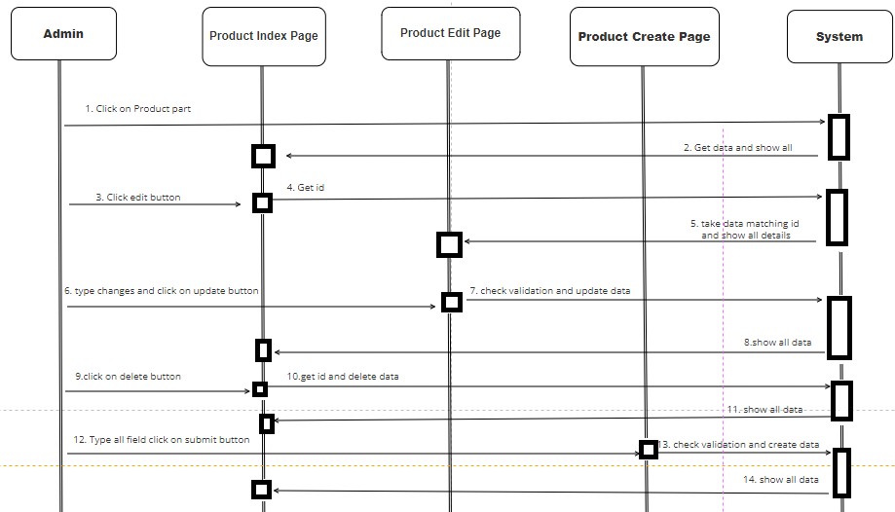

|  |  |  |
| --- | --- | --- |
| **Author** | Trần Phạm Duy Thanh | |
| **Use** **case** **name** | Manage Post | |
| **Actors** | Admins | |
| **Description** | Admin can see, search, sort, create, edit, delete post. | |
| **Requirement** | Login | |
|  | **Actor** **action** | **System** **responses** |
| **Basic flow** | Click on post index to see all post data.  Click on edit button enter content what you want to change and click on submit button.  Click on delete button to delete post.  Type and click on submit to create new post.  Enter keyword to search post.  Click on table header to sort data. | System takes all post data and show all.  System will redirect to edit page, check validation and update data after admins click on update button.  System deletes post was chosen in database.  System check validation and create data.  System check keyword and show matching entities.  System sort data by name, id, status… |
| **Exception** | Field name not blank.  Name unique.  Field content not blank.  Image format. | Display error message:  “This value is required”  “This value is existed”  “This value is required”  “Image must be jpg, png” |

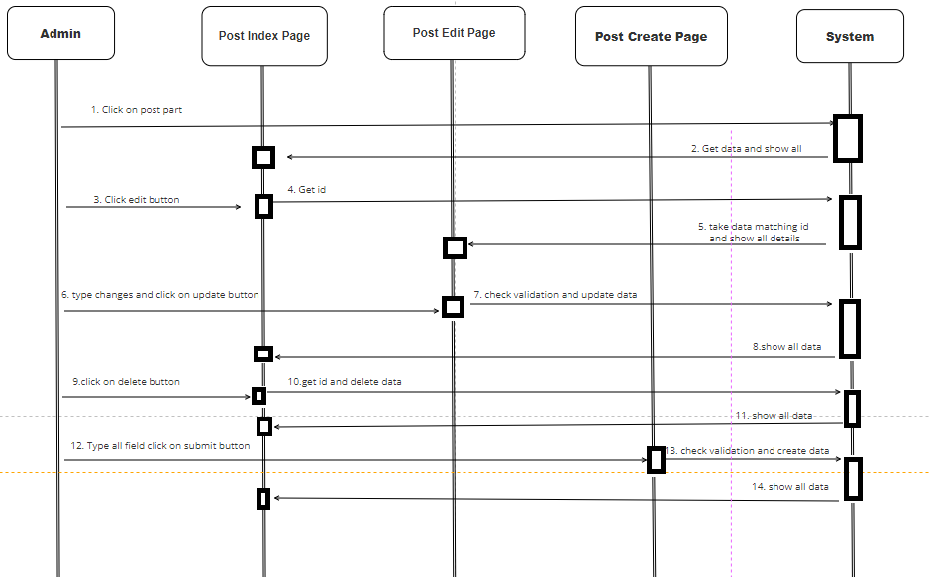

|  |  |  |
| --- | --- | --- |
| **Author** | Trần Phạm Duy Thanh | |
| **Use** **case** **name** | Manage Comment | |
| **Actors** | Admins | |
| **Description** | Admin can see, search, sort, delete comment. | |
| **Requirement** | Login | |
|  | **Actor** **action** | **System** **responses** |
| **Basic flow** | Click on comment index to see all comment data.  Click on delete button to delete comment.  Enter keyword to search comment.  Click on table header to sort data. | System takes all post data and show all.  System deletes comment was chosen in database.  System check keyword and show matching entities.  System sort data by name, id, status… |
| **Exception** |  |  |

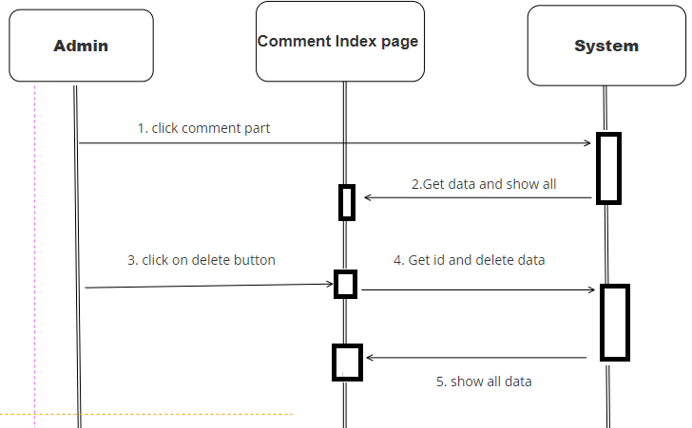

|  |  |  |
| --- | --- | --- |
| **Author** | Trần Phạm Duy Thanh | |
| **Use** **case** **name** | Manage Order | |
| **Actors** | Admins | |
| **Description** | Admin can see, search, sort, view, export, delete order. | |
| **Requirement** | Login | |
|  | **Actor** **action** | **System** **responses** |
| **Basic flow** | Click on order index to see all order data.  Click on delete button to delete order.  Click on view button to see order detail.  Click on export to down file pdf order detail.  Enter keyword to search order.  Click on table header to sort data. | System takes all order data and show all.  System deletes order was chosen in database.  System get id, take data and show order detail.  System get id, take data and download file pdf.  System check keyword and show matching entities.  System sort data by name, id, status… |
| **Exception** |  |  |

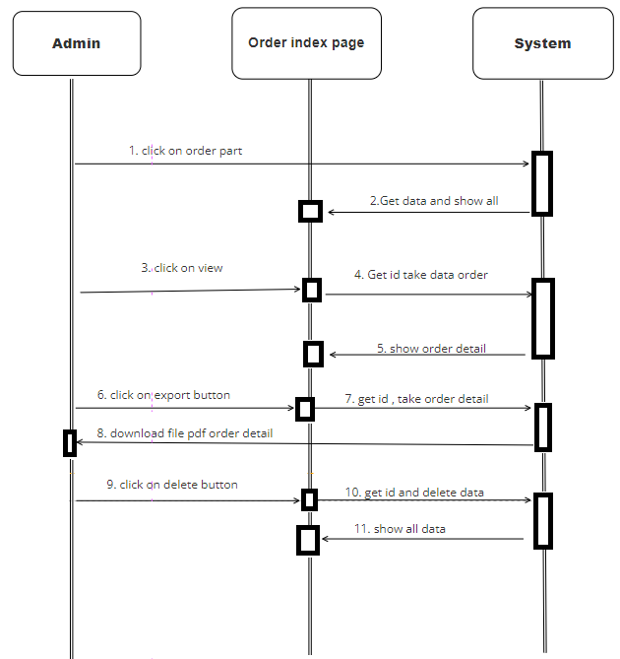

|  |  |  |
| --- | --- | --- |
| **Author** | Trần Phạm Duy Thanh | |
| **Use** **case** **name** | Manage setting | |
| **Actors** | Admins | |
| **Description** | Admin can see, search, sort, create, edit, delete setting | |
| **Requirement** | Login | |
|  | **Actor** **action** | **System** **responses** |
| **Basic flow** | Click on setting index to see all setting data.  Click on edit button enter content what you want to change and click on submit button.  Click on delete button to delete setting.  Type and click on submit to create new setting.  Enter keyword to search setting.  Click on table header to sort data. | System takes all setting data and show all.  System will redirect to edit page, check validation and update data after admins click on update button.  System deletes setting was chosen in database.  System check validation and create data.  System check keyword and show matching entities.  System sort data by name, id, status… |
| **Exception** | Field config key not blank.  Name key unique. | Display error message:  “This value is required”  “Category is existed” |

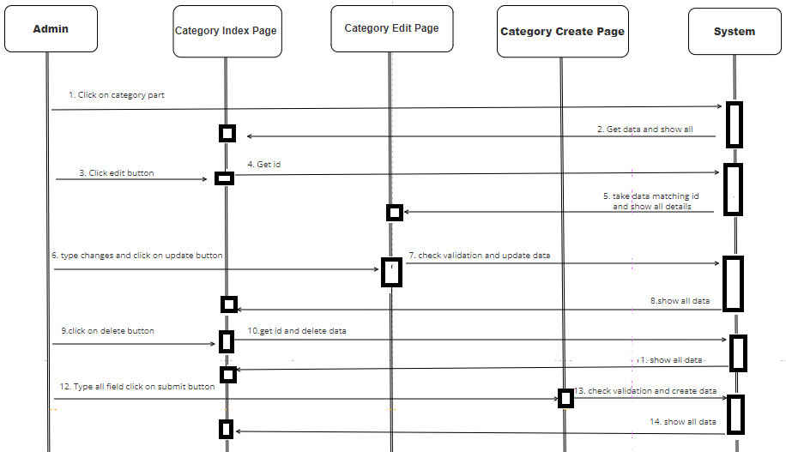

|  |  |  |
| --- | --- | --- |
| **Author** | Trần Phạm Duy Thanh | |
| **Use** **case** **name** | Manage user | |
| **Actors** | Admins | |
| **Description** | Admin can see, search, sort, create, edit, delete user | |
| **Requirement** | Login | |
|  | **Actor** **action** | **System** **responses** |
| **Basic flow** | Click on user index to see all user data.  Click on edit button enter content what you want to change and click on submit button.  Click on delete button to delete user.  Type and click on submit to create new user.  Enter keyword to search user.  Click on table header to sort data. | System takes all user data and show all.  System will redirect to edit page, check validation and update data after admins click on update button.  System deletes user was chosen in database.  System check validation and create data.  System check keyword and show matching entities.  System sort data by name, id, status… |
| **Exception** | Field name not blank.  Name format.  Field email not blank.  Email format.  Email unique.  Field password required.  Field address required.  Field phone required.  Phone format. | Display error message:  “This value is required”  “This value must be format”  “This value is required”  “This value is required”  “Email is already existed”  “This value is required”  “This value is required”  “This value is required”  “This value is required” |

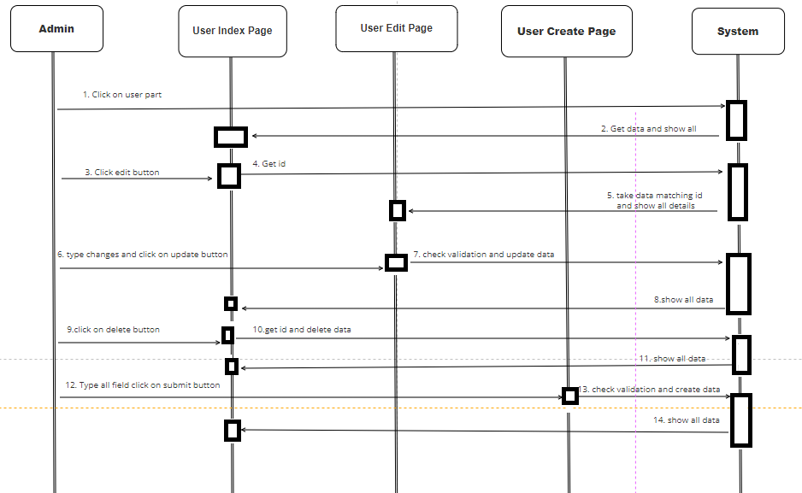

## Flowchart

### Login function(user)

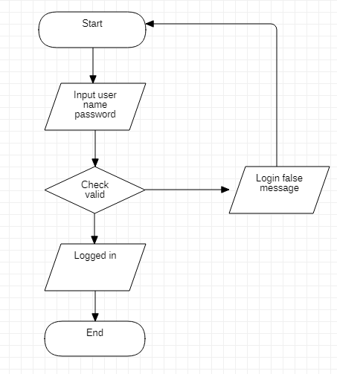

### Signup function (user)

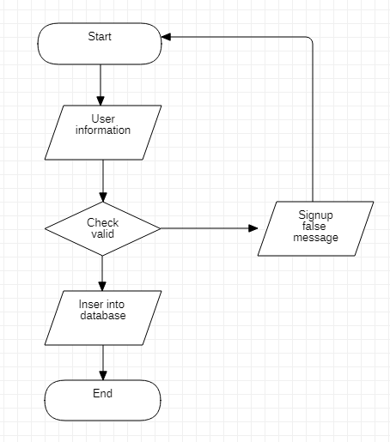

### Search function

### View data function

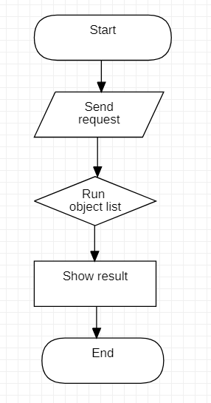

### Insert data function

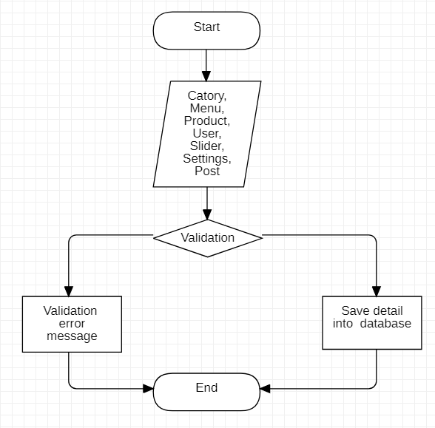

### Login function(admin)



## Sitemap

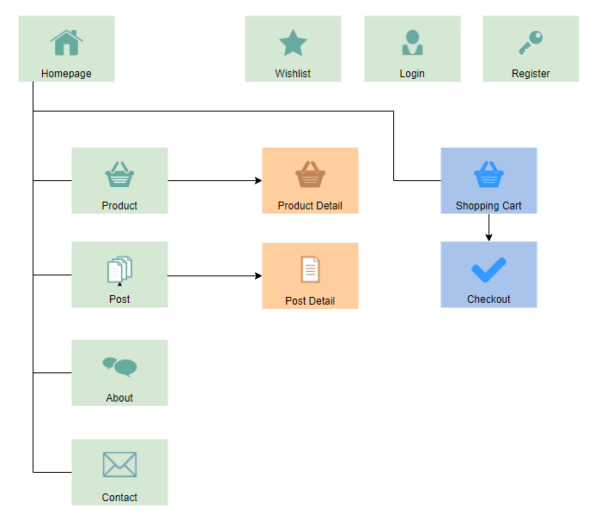

## TABLE DESIGN

### 1.Table categories

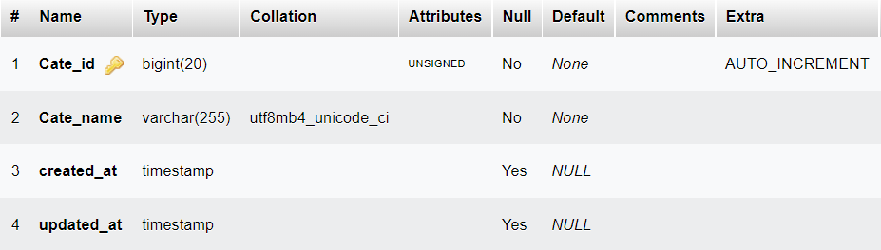

### 

### 2.Table foods

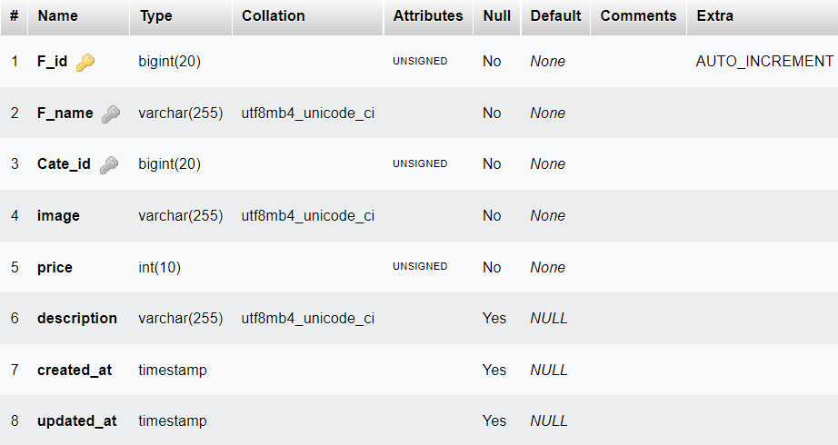

### 3.Table orders

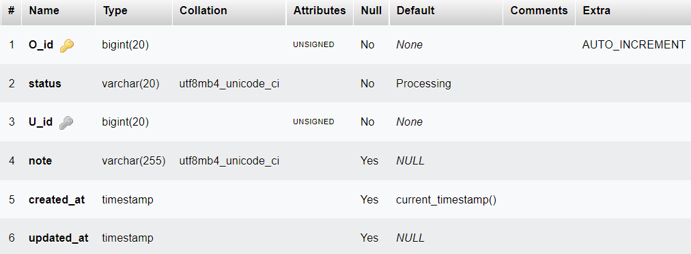

### 4.Table order_detail

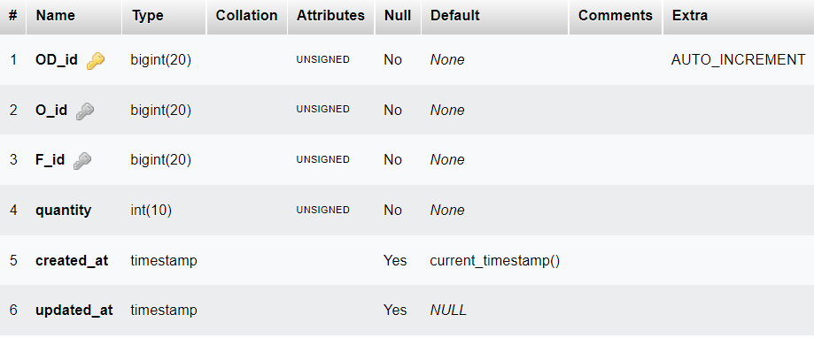

### 5.Table posts

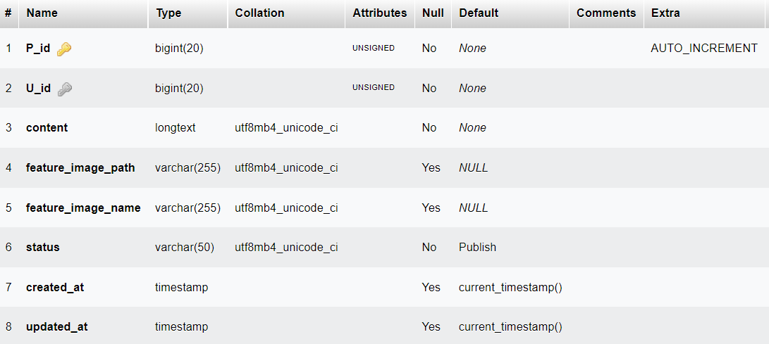

### 

### 6.Table comments

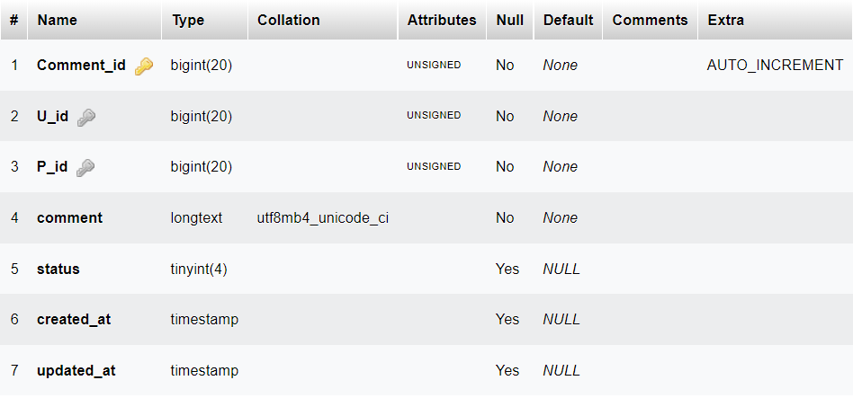

### 7.Table foods_images

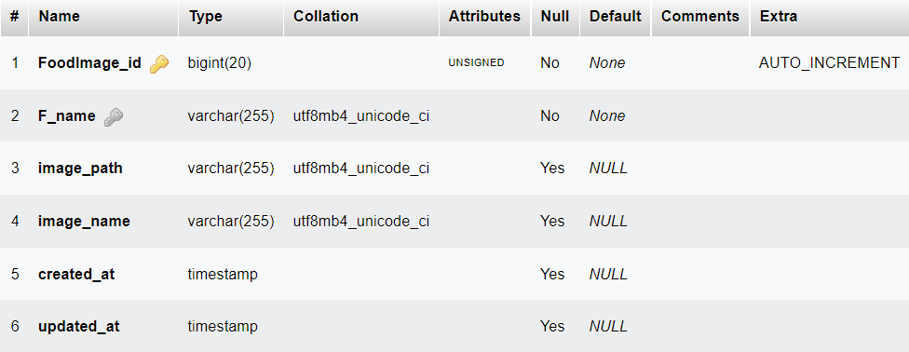

### 8.Table users

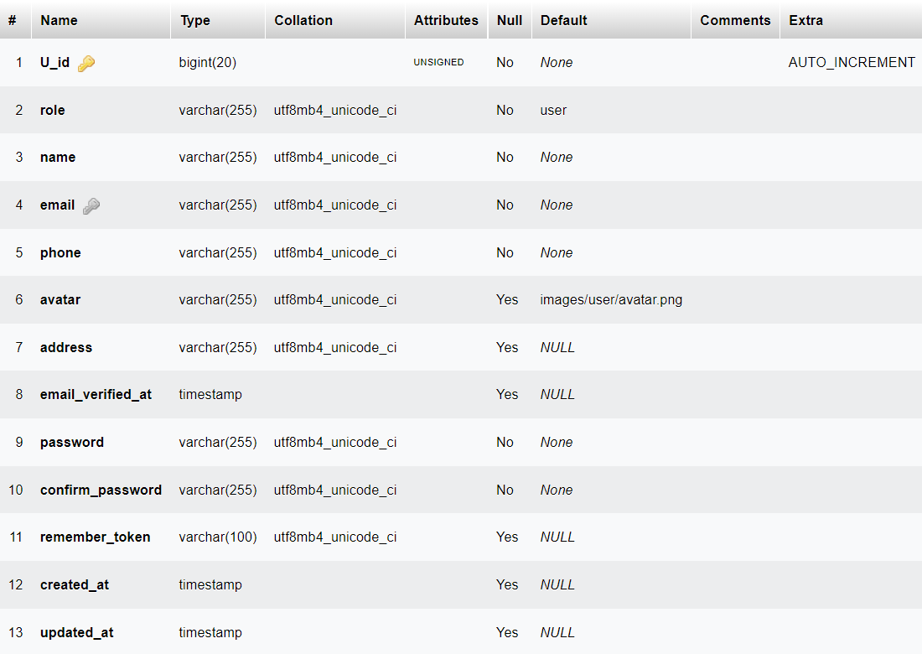

### 9. Table wishlist

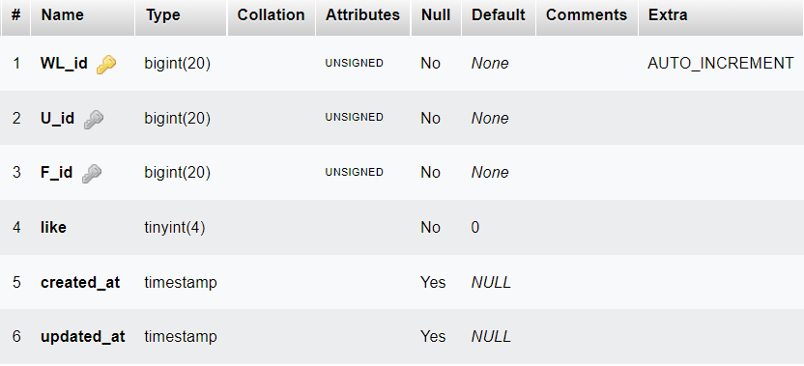

### 10. Table rating

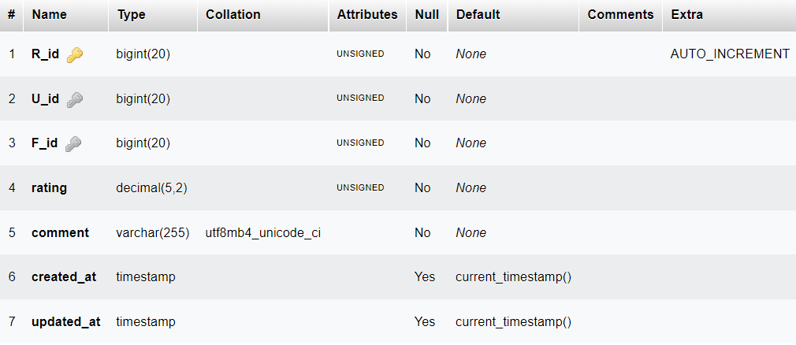

### 11. Table calories

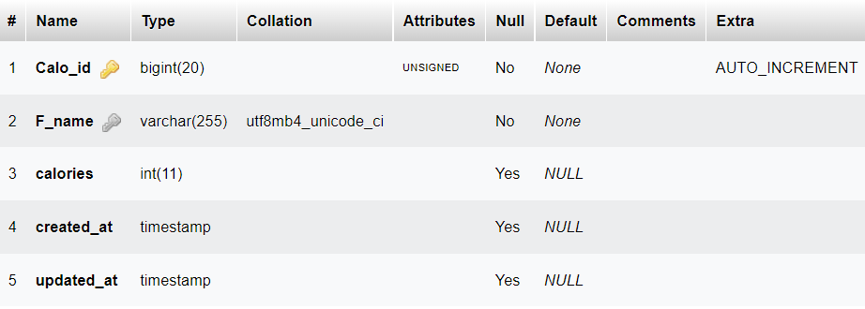

## RELATIONSHIP DIAGRAM

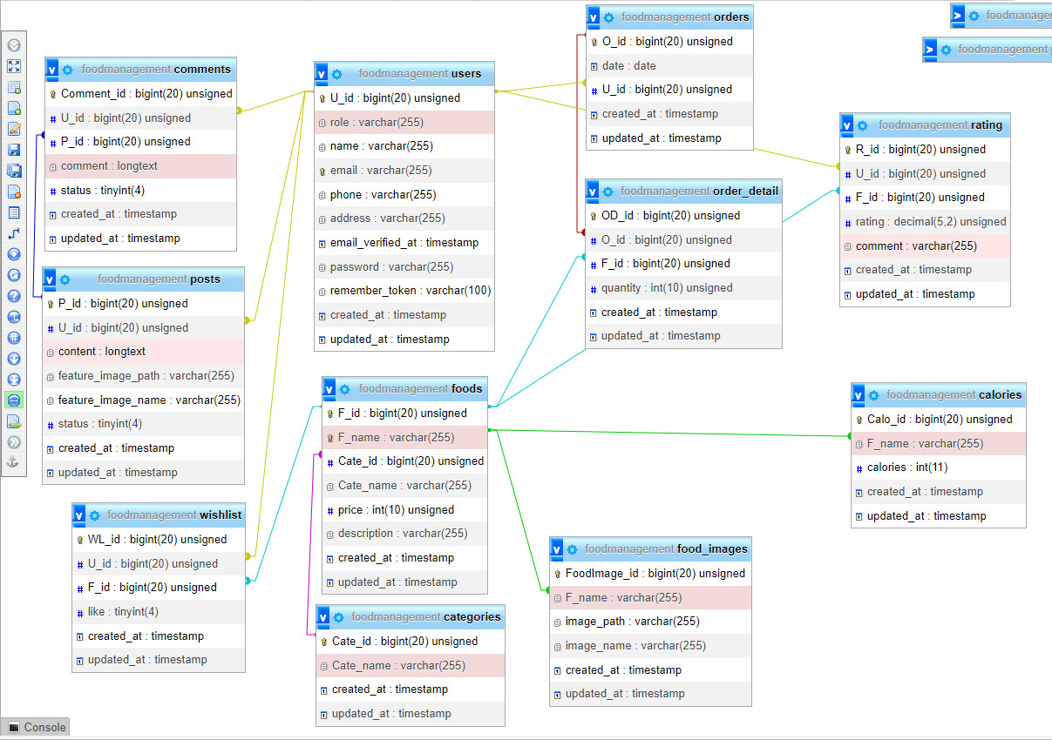

# REVIEW 3

# Customer

# I. Home Page

## 1.Home

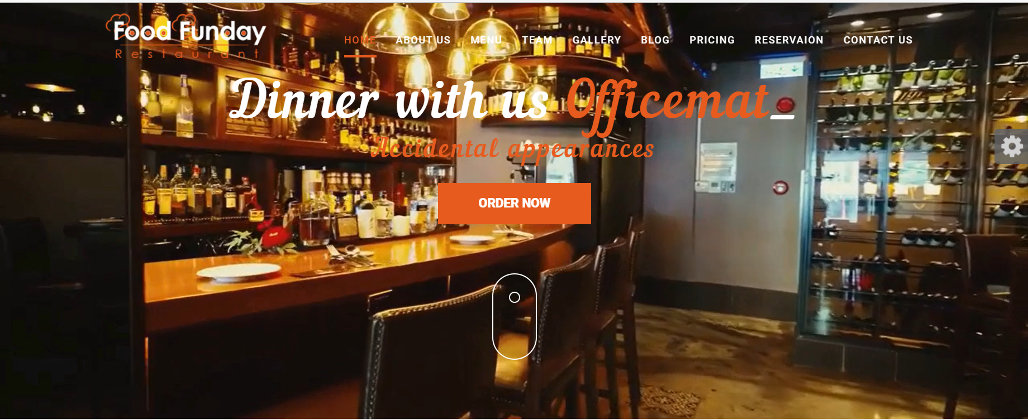

## 2.About Us

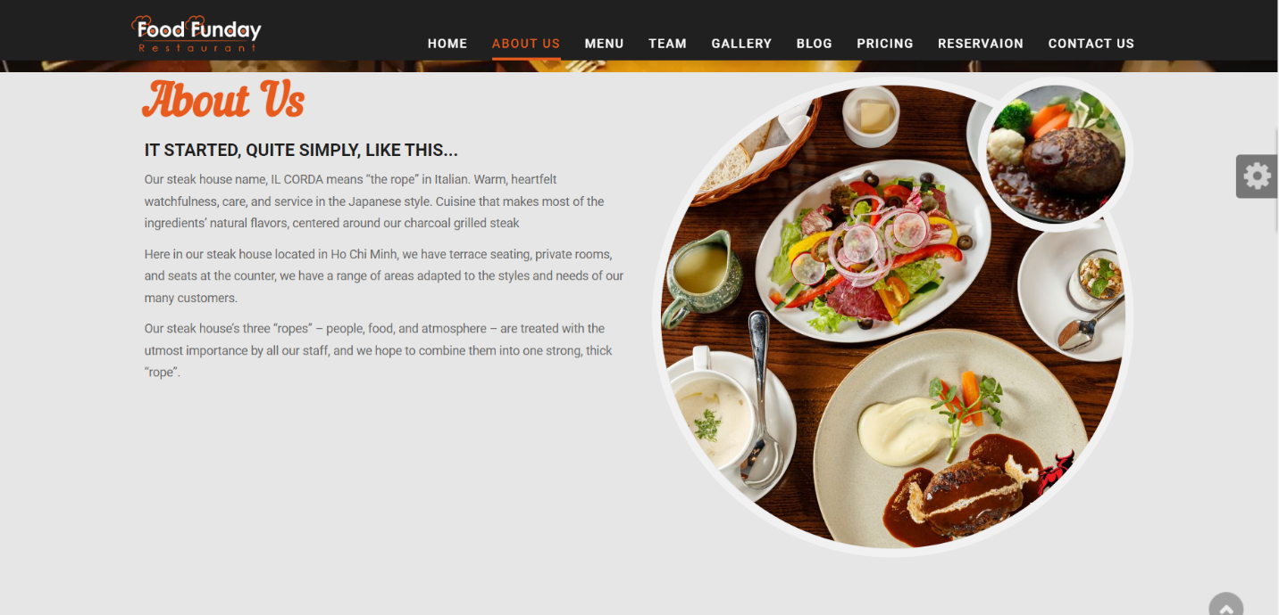

## 3.Menu

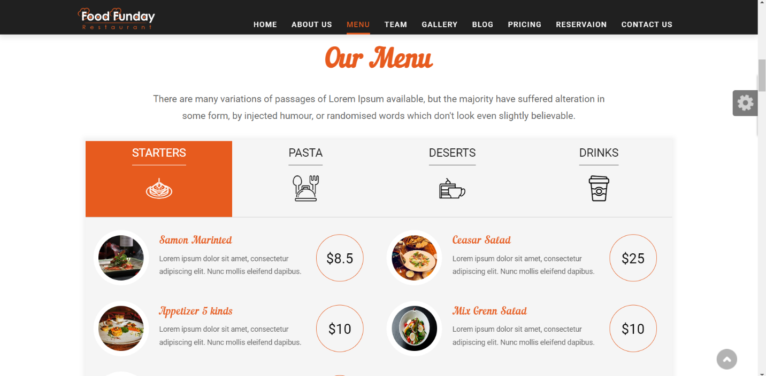

## 4.Team

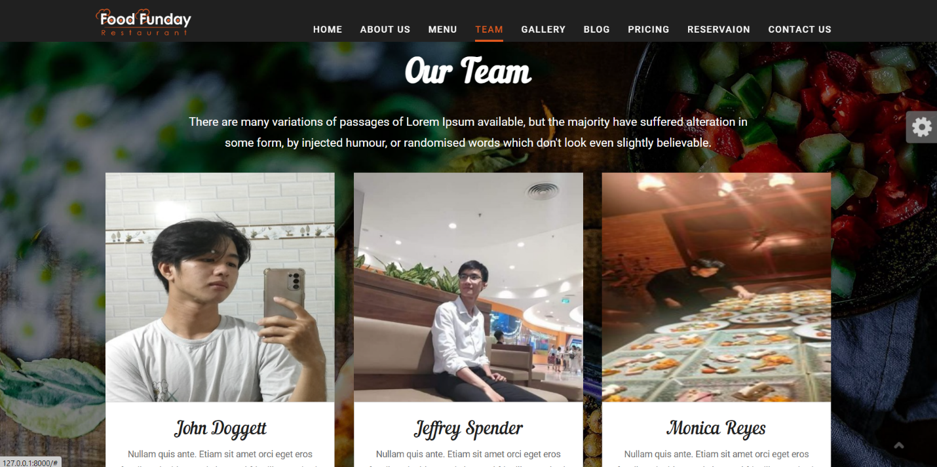

## 5.Our Gallery

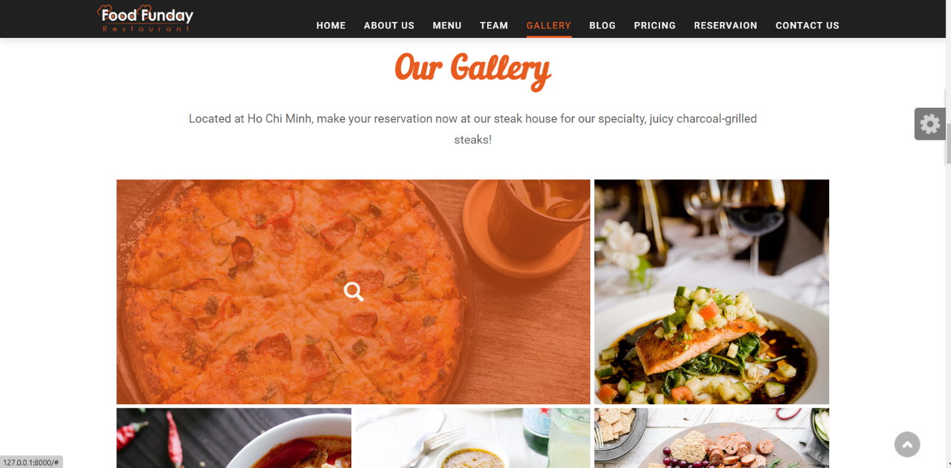

## 6.Hot Deal

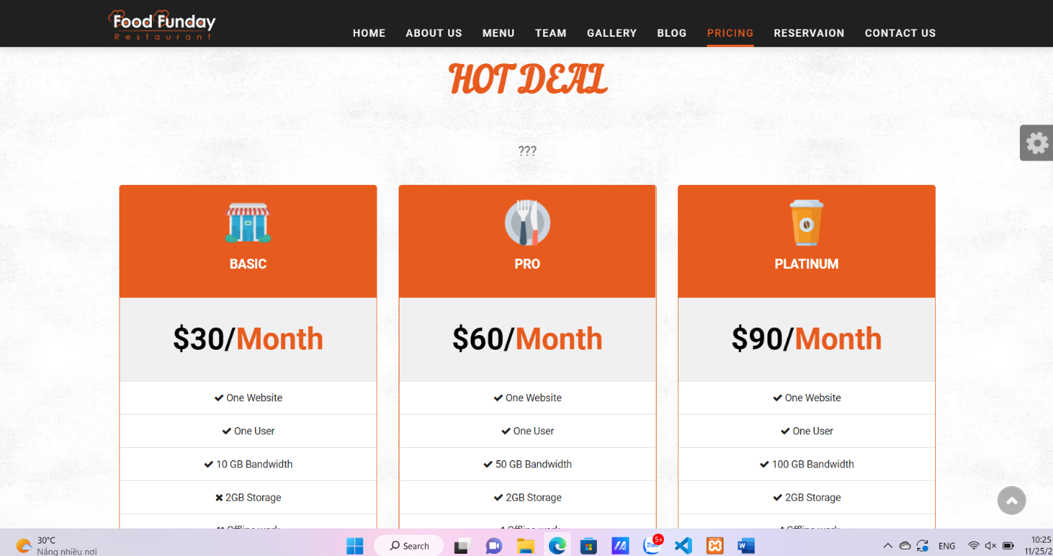

## 7.Blog

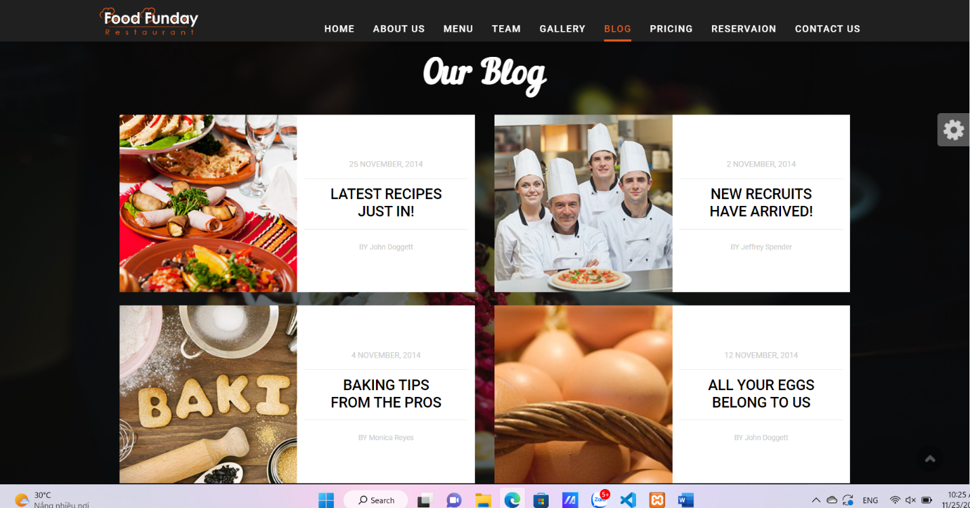

## 8.Revervation

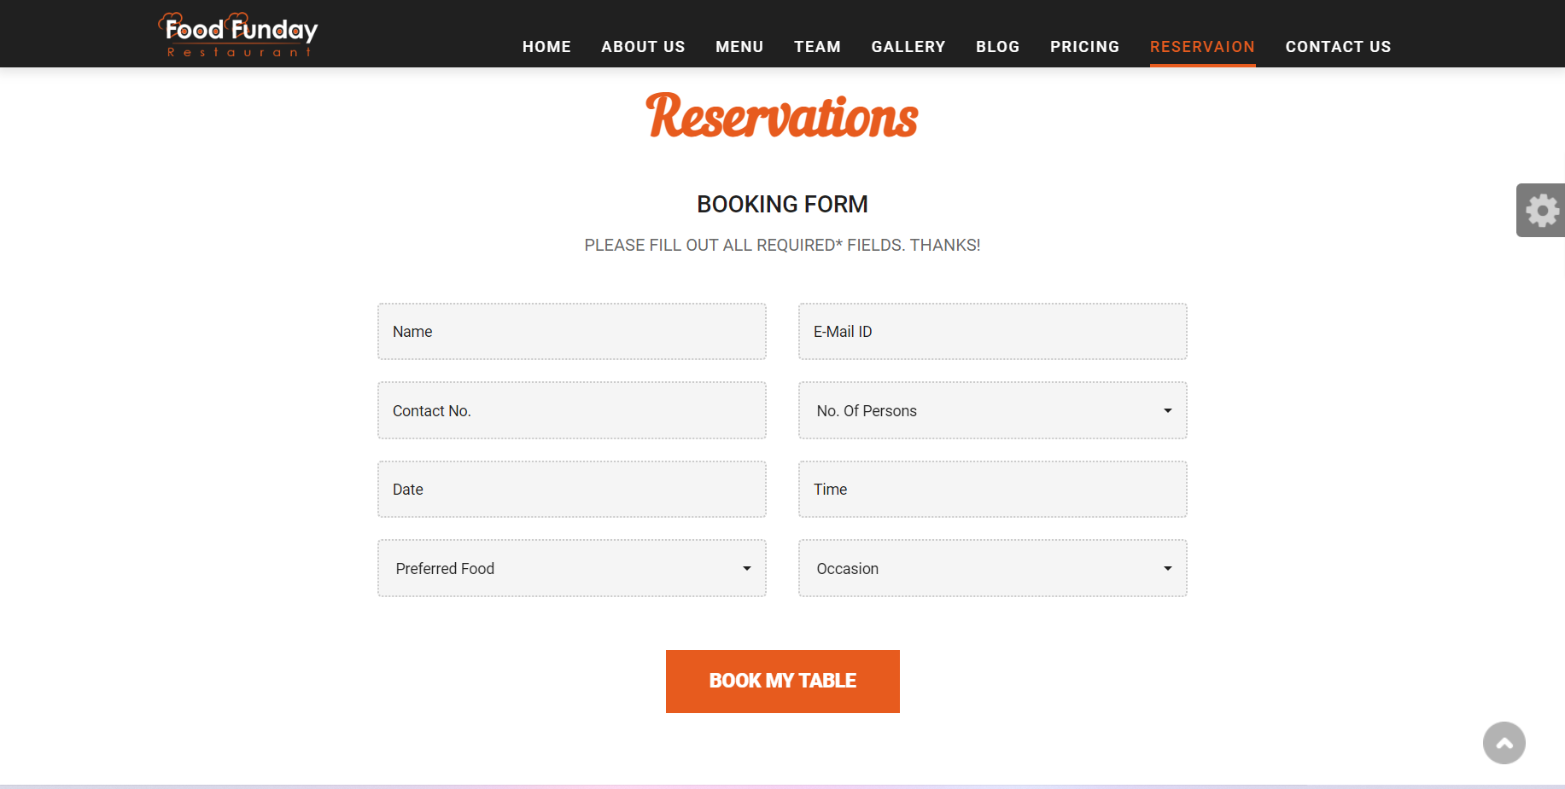

## 9.Contact Us

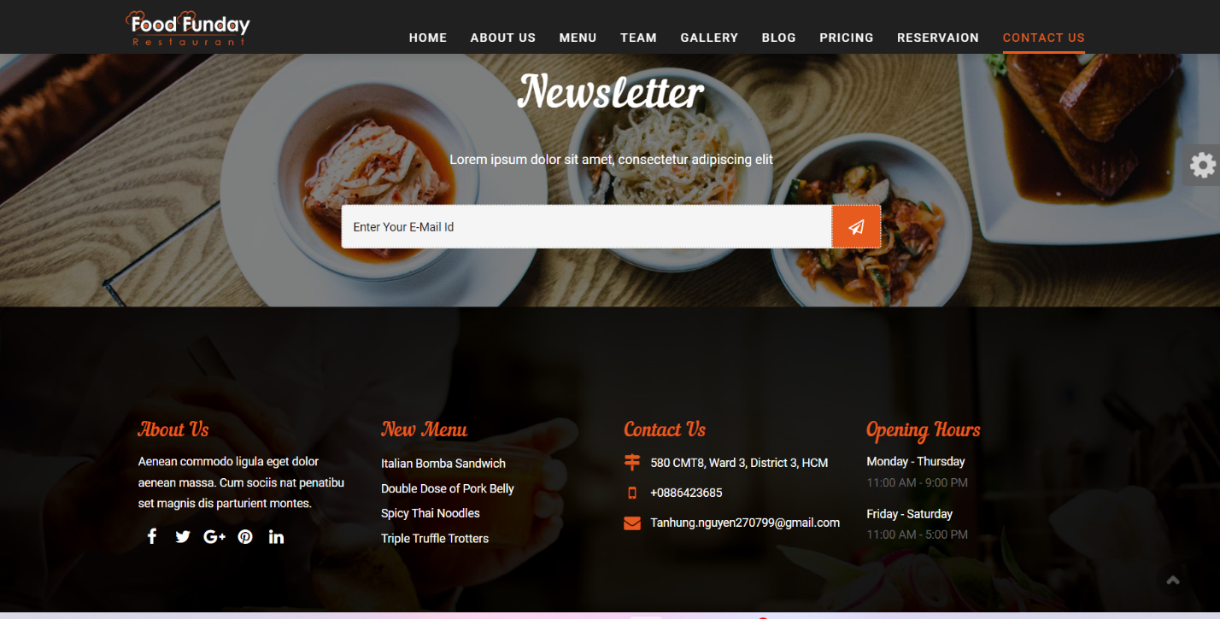

## 10.Login



## II. Product

## 2.Product page

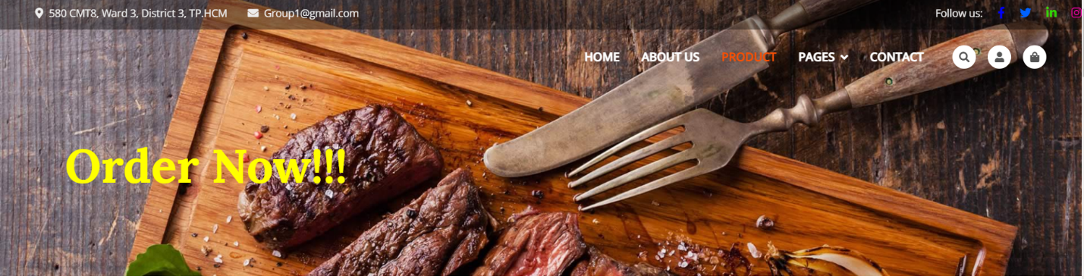

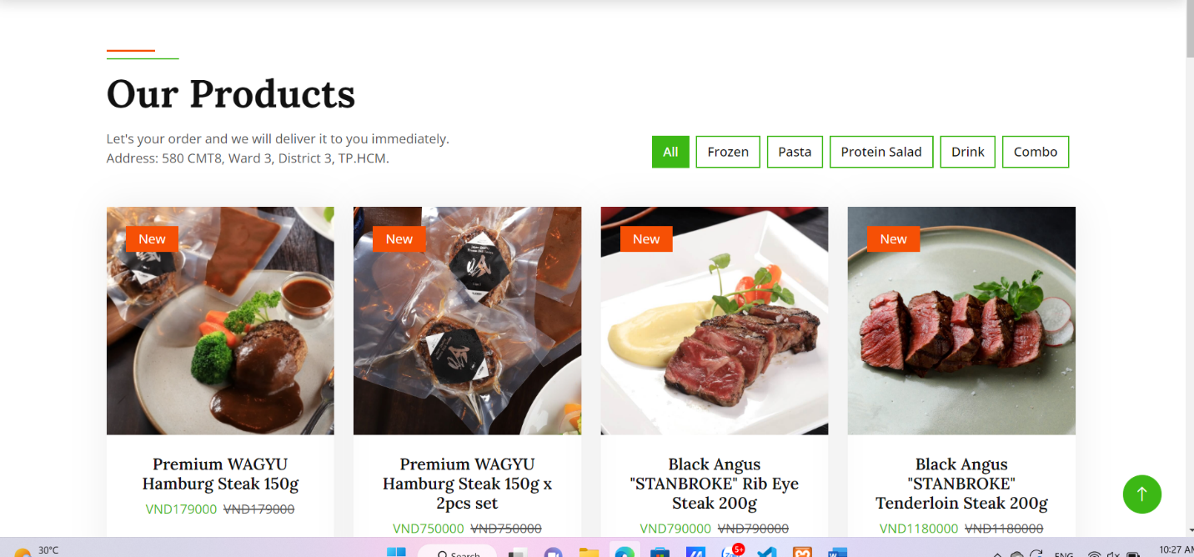

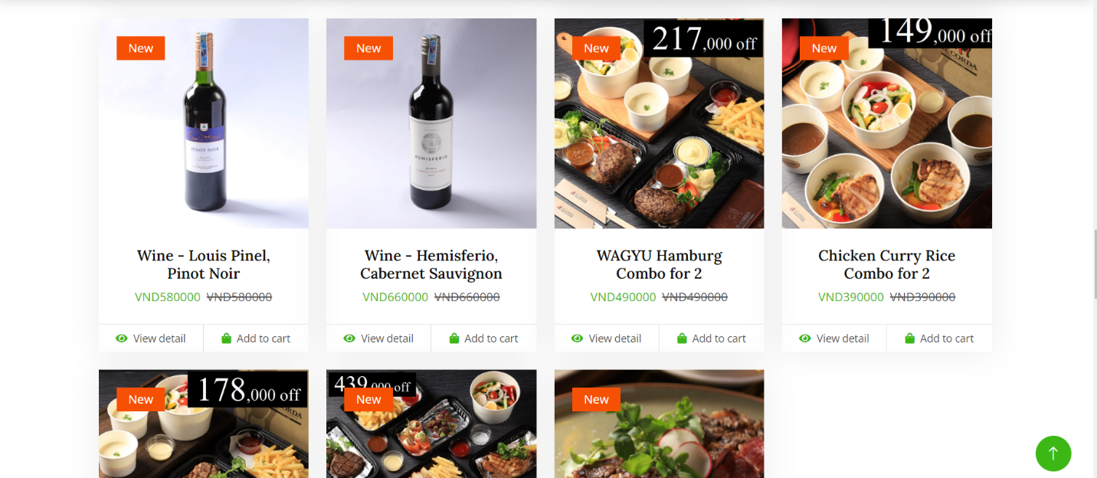

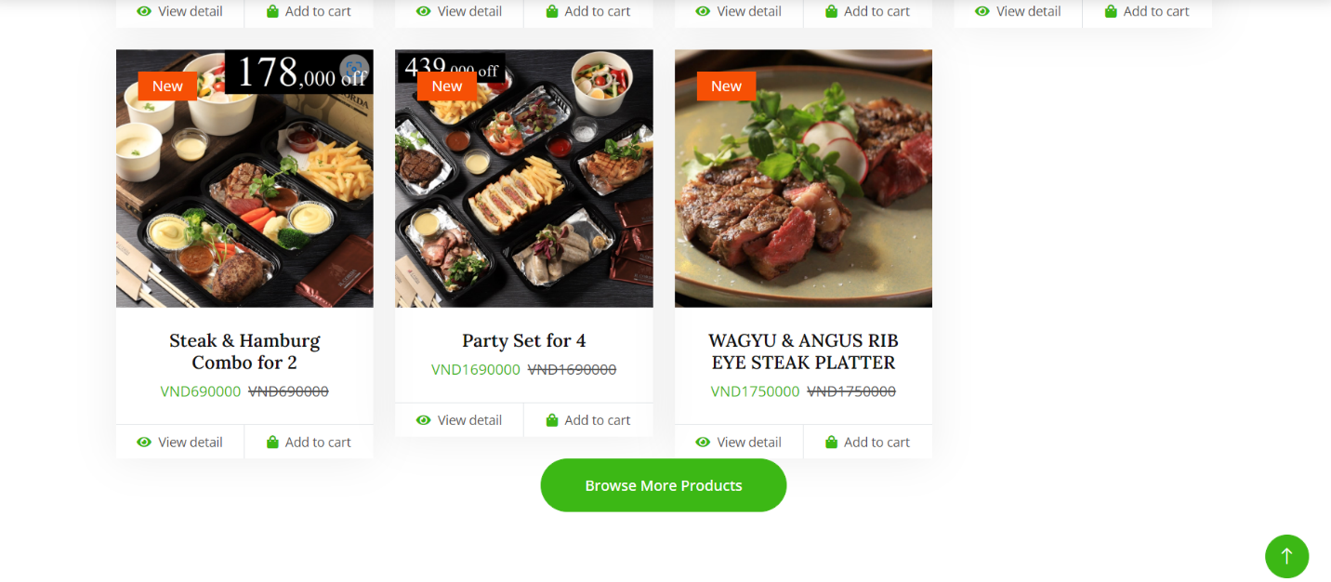

## 3. Product detail page

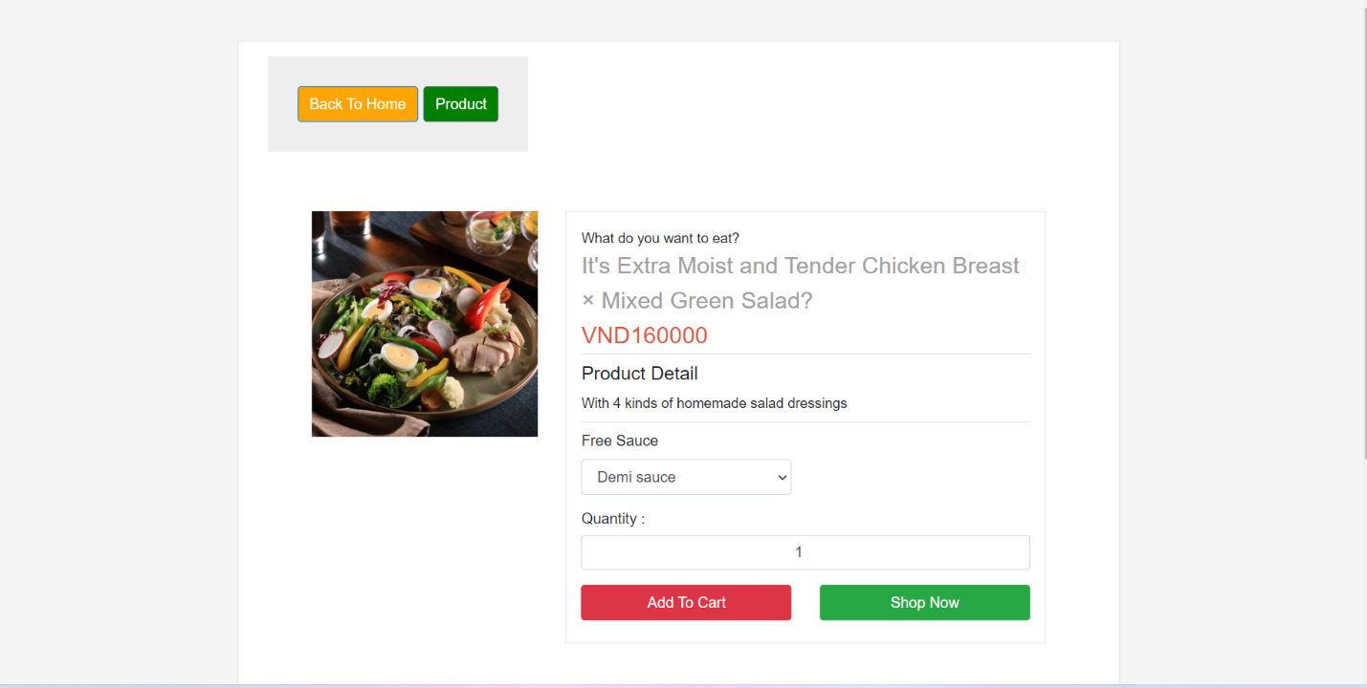

## III. Admin

## 1. Home

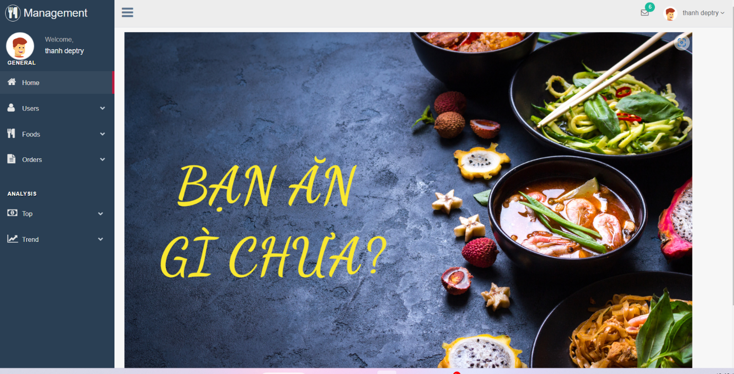

## 2. Management Food

## *a. All Food*

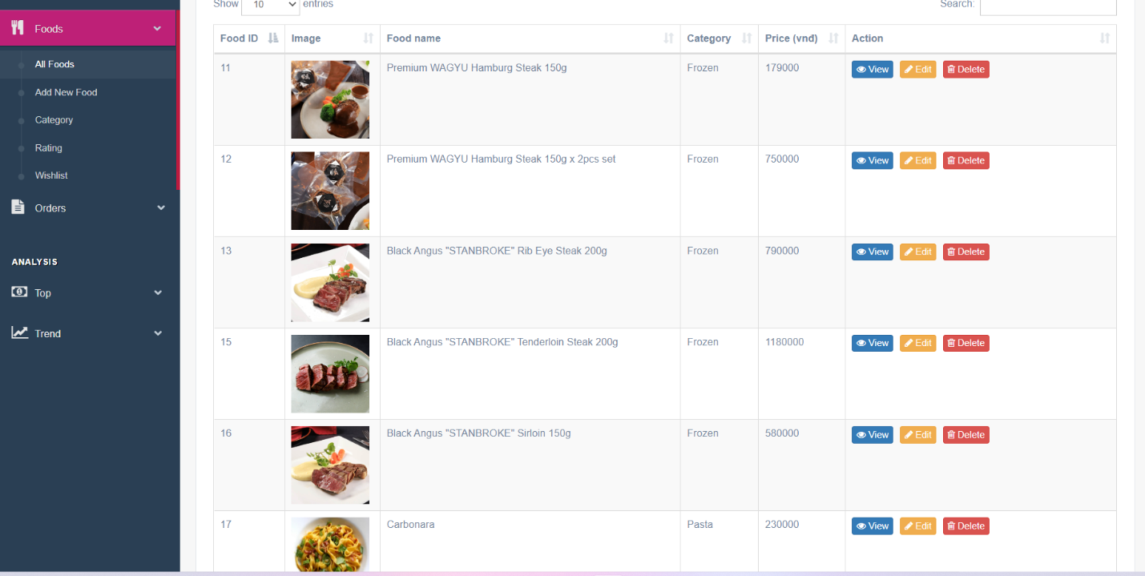

## *b. Add New Food*

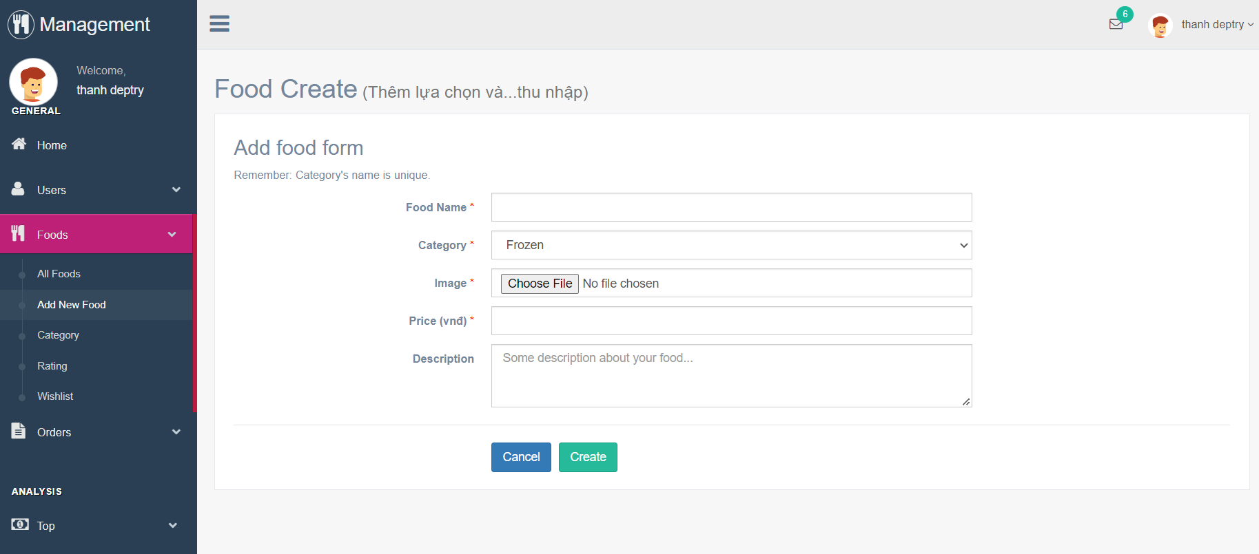

## *c. All Categories*

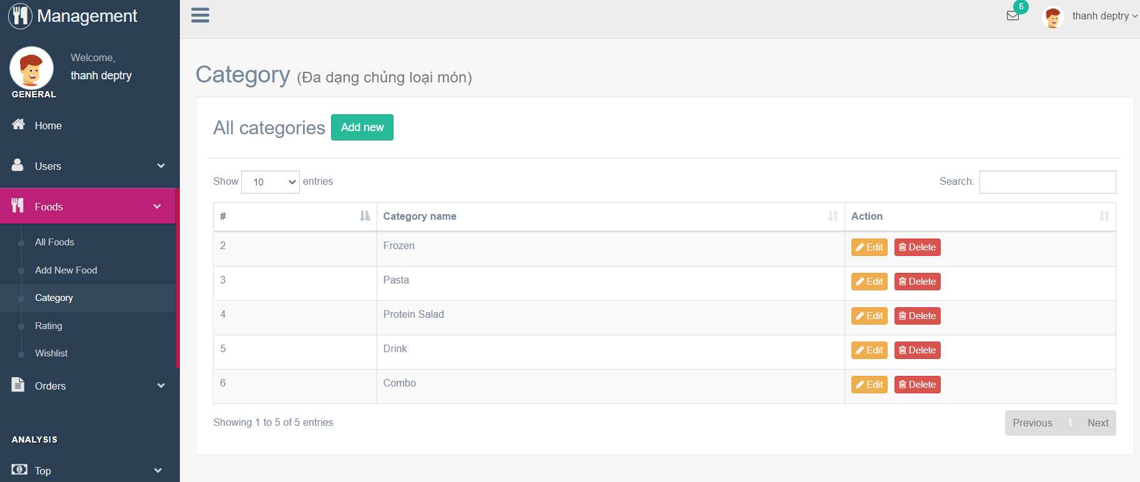

# Task Sheet

|  |  |  |  |  |
| --- | --- | --- | --- | --- |
| Project Ref.No | Project Name: Food Store | Date of Preparation of Activity Plan | | |
| No | Description | Start date | Complete date | Team Member |
|  | Admin-Template | 2022/11/05 | 2022/11/06 |  |
|  | Admin-Login/Logout | 2022/11/06 | 2022/11/07 |
|  | Admin-Category | 2022/11/07 | 2022/11/08 |
|  | Admin-Food | 2022/11/08 | 2022/11/09 |
|  | Admin-User | 2022/11/09 | 2022/11/10 |
|  | Admin-Payment VNpay | 2022/11/10 | 2022/11/21 |
|  | Admin- Payment Momo | 2022/11/11  Trần Phạm Duy Thanh  Hoài  Hoài | 2022/11/22 |
|  | Admin-Orders | 2022/11/12 | 2022/11/13 |
|  | Admin-Dashboard | 2022/11/13 | 2022/11/08 |
|  | Admin-Analysis Cate | 2022/11/14 | 2022/11/09 |
|  | Admin-Analysis User | 2022/11/15 | 2022/11/20 |
|  | Admin-Analysis Food | 2022/11/16 | 2022/11/21 |
|  | Admin-Analysis Revenue | 2022/11/17 | 2022/11/22 |
|  | Member-Login | 2022/11/18 | 2022/11/21 |
|  | Member -Logout | 2022/11/19 | 2022/11/22 |
|  | Member-Rating | 2022/11/20 | 2022/11/55 |
|  | Member-Wishlist | 2022/11/21 | 2022/11/26 |
|  | Member-Process orders |  |  |  |
|  | Create-Tables |  |  |
|  | Review 1 |  |  |
|  | Admin-Slidebar |  |  | Nguyễn Tấn Hùng  Hoài  Hoài |
|  | Admin-Menu |  |  |
|  | Admin-User |  |  |
|  | Admin-Create Seeder |  |  |
|  | Admin-Slider |  |  |
|  | Admin-Post |  |  |
|  | Admin-Comment |  |  |
|  | Guest-Template |  |  |
|  | Guest-Show Menu |  |  |
|  | Guest-Show Food |  |  |
|  | Guest-Show Post |  |  |
|  | Guest-Register |  |  |
|  | Guest-Compare |  |  |
|  | Review 3 |  |  |
|  | Report-Food |  |  |
|  | Guest-Template |  |  |
|  | Guest-Show Menu |  |  |
|  | Guest-Show Product |  |  |
|  | Review 2 |  |  |  |
|  | Guest-About |  | Nguyễn Quang Trường |
|  | Guest-Contact |  |  |
|  | Member-Posts |  |  |
|  | Member-Comment |  |  |